**MUNA Matrimonial Website User Guide Line**

Welcome to Muna Matrimonial. If you feel interested about us please visit the website and if you think it is helpful for you and your Muslim Community you can join with us maintaining the following procedure. Visit: https://munamatrimonial.com

Read the instruction carefully. Please provide appropriate and authentic data to get the best outcomes.

Where you find ‘*’ and red marked box don’t forget to put information there.

1. When you visit our website you can see the following window. According to your desire you can select the gender and age range then click below button.

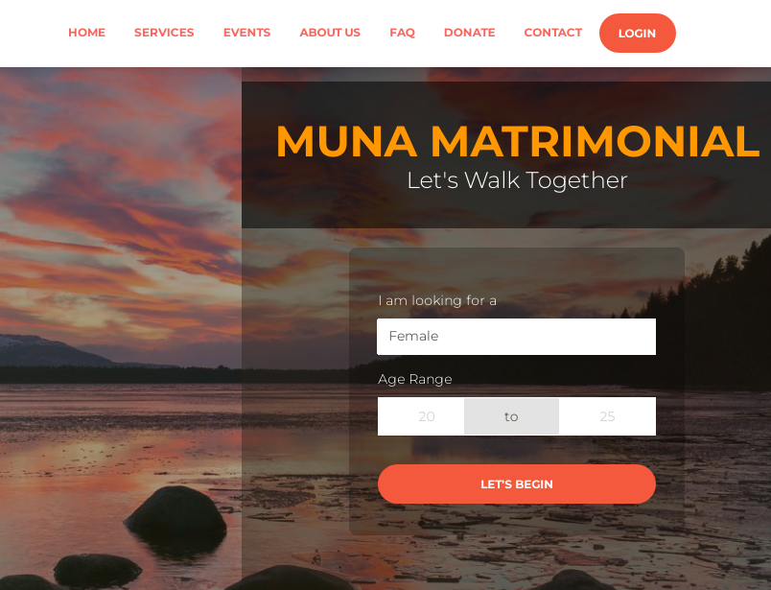

2. If you want to take registration please put the information in the following form. After filling the information click the confirmation button.

** Password should minimum 8 characters and must contain at least one uppercase, one lowercase, one number and one special character.

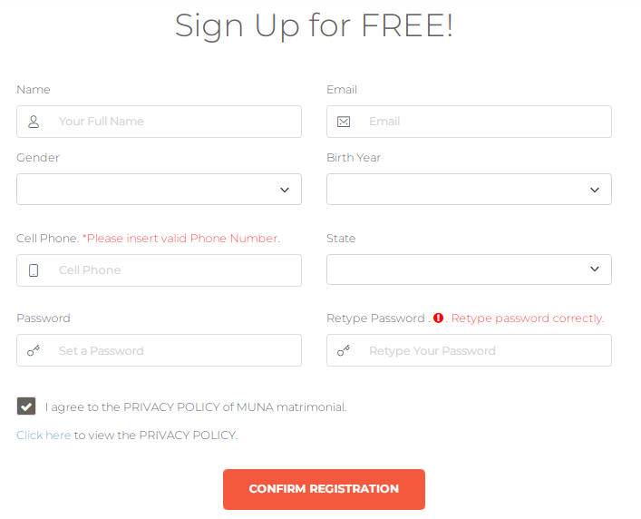 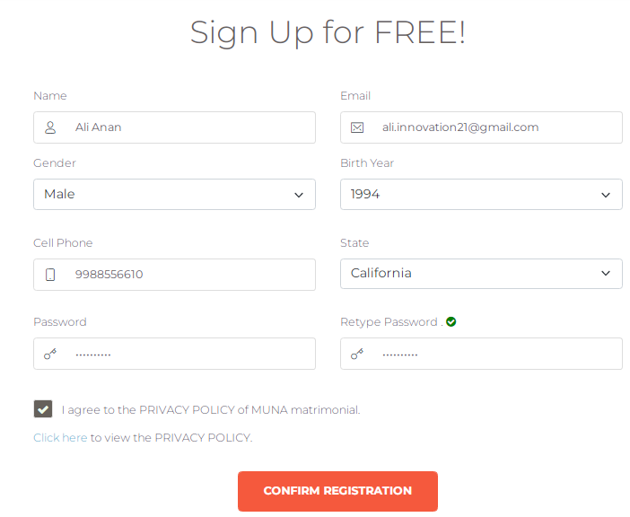

3. When you click CONFIRM REGISTRATION a verification code is send to your email. Enter the verification code and click VERIFY EMAIL.

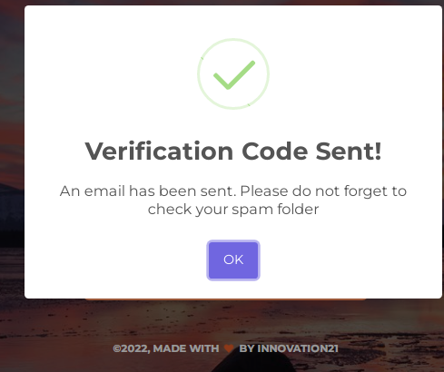 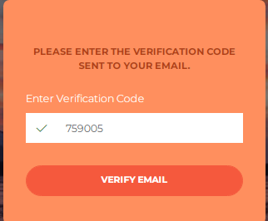

4. When verification is complete your registration is successful and you are able to login in your profile. Put your email and password then click login button such as bellow.

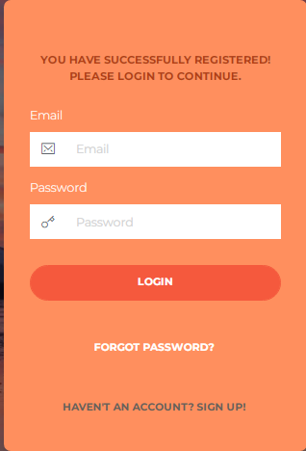 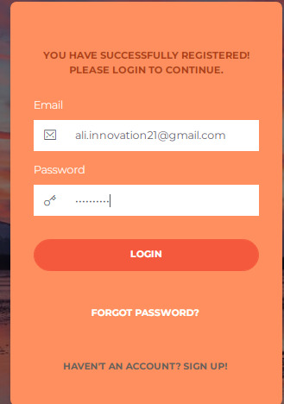

5. When a user registered first, his/her profile is INACTIVE. He/she need to complete his/her profile. Complete your profile accurately for best outcomes.

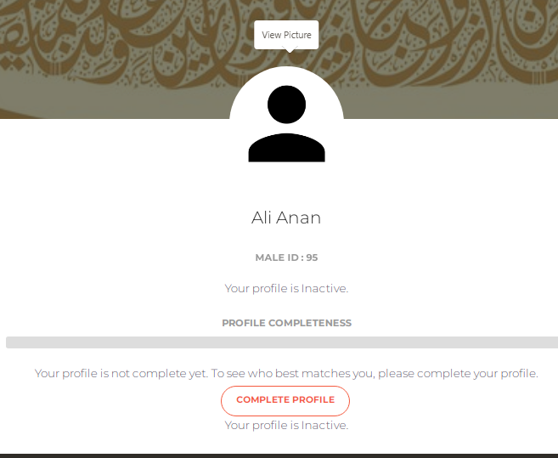 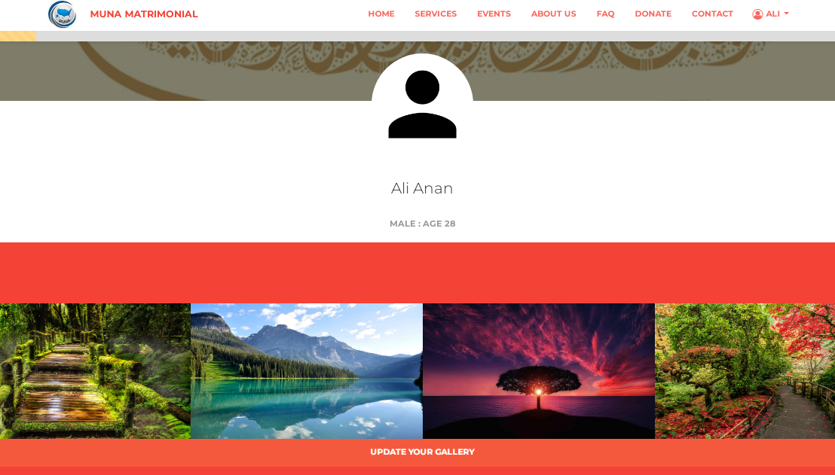

6. Add profile picture, upload some photos to update your gallery. Put your information in all section correctly.

6.1. Edit General Information

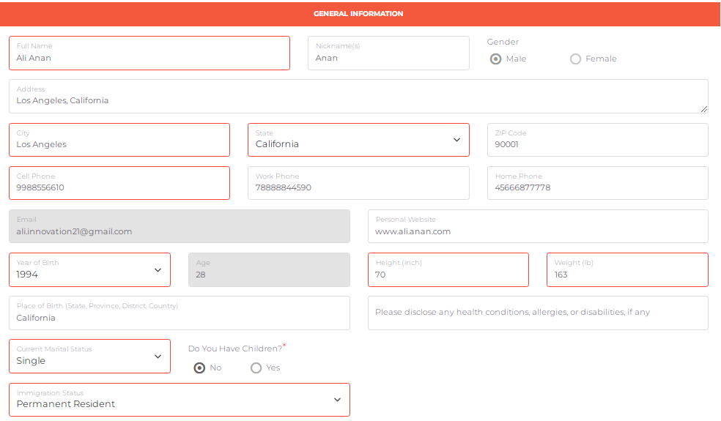

6.2. Edit Academic & Professional Background.

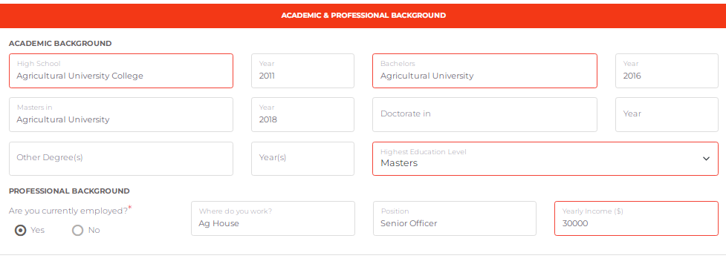

6.3. Edit Parents / Guardians Information.

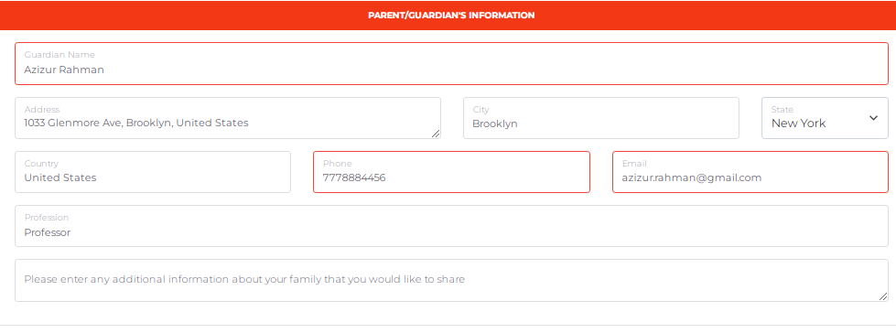

6.4. Edit Personal Information.

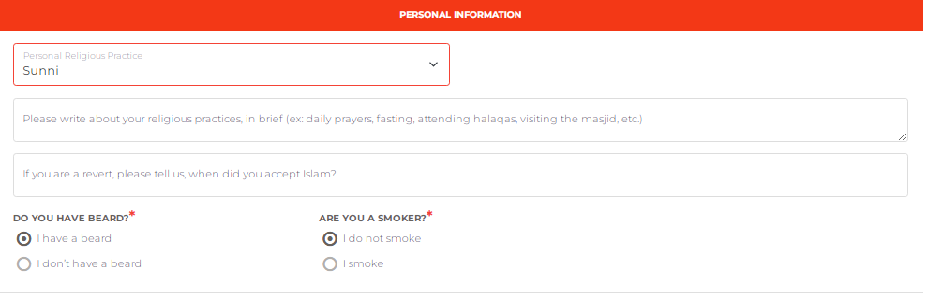

6.5. Edit Spouse Preferences very carefully.

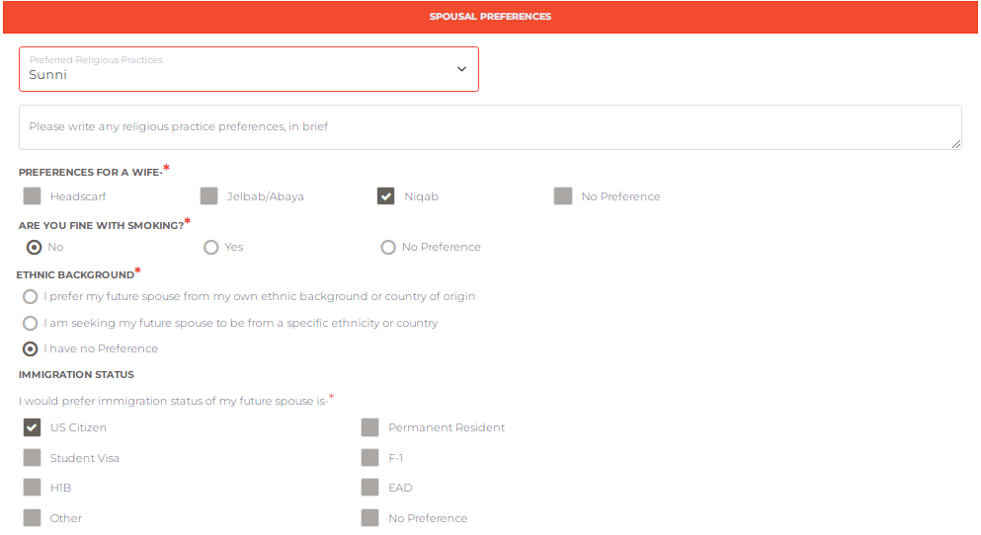

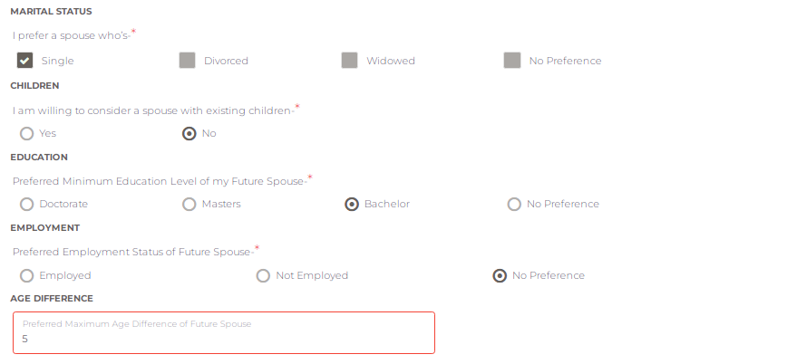

6.6. Edit Additional Information.

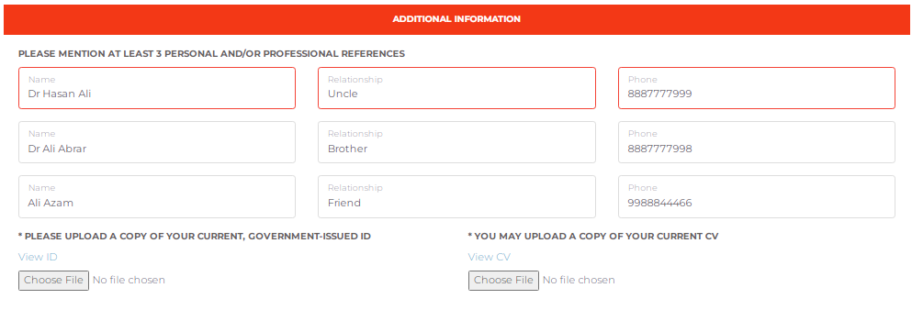

6.7. Read the agreement very carefully, upload your signature and click save.

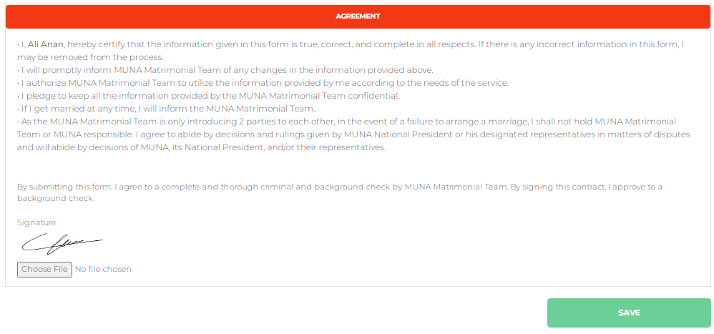

7. When profile percentage reached to 90%, an automatic notification will be sent to admin to ACTIVATE your account. Before admin approval your profile will be pending

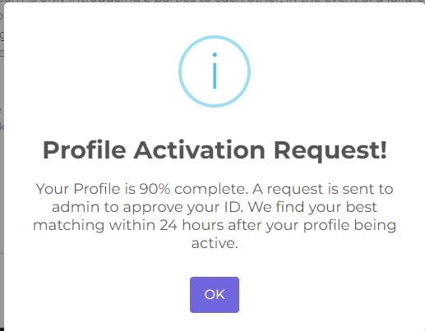 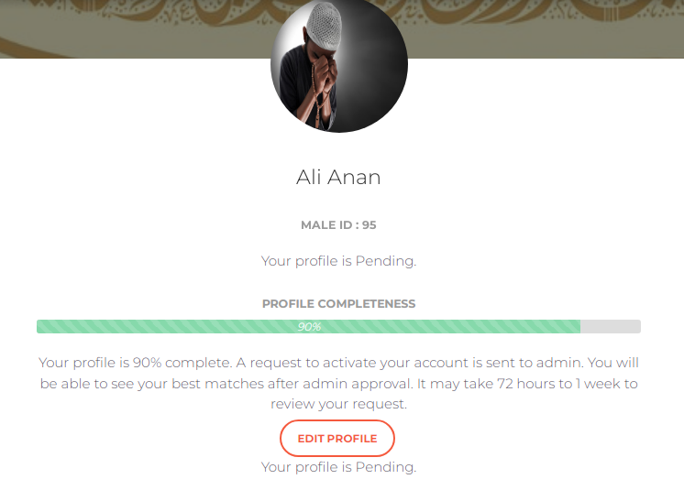

8. After approval your profile is active and you can see the top matches within 24 hours after activating your profile. Your profile is visible to anyone who has access to view your profile. You can also send request to view their profile. You have to wait for admin Approval.

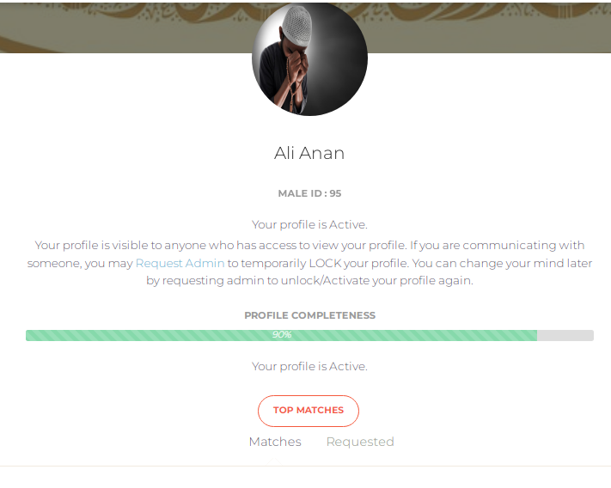 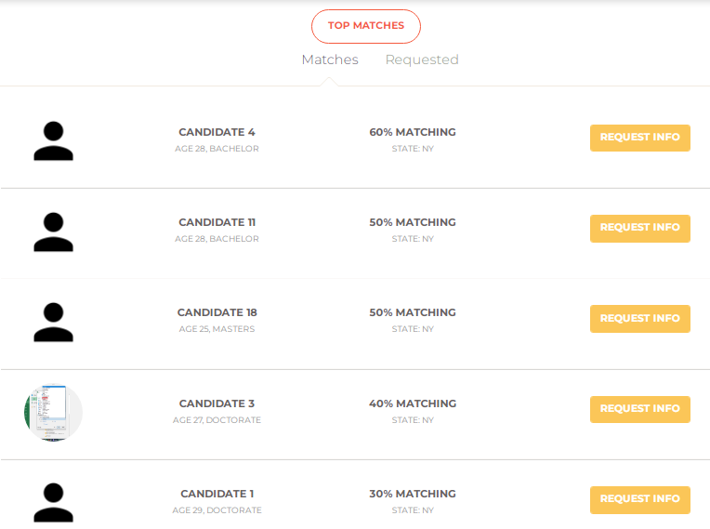

9. If you are communicating with someone, you may Request Admin to temporarily LOCK your profile. You can change your mind later by requesting admin to unlock/Activate your profile again.

